Title of the article (article title should be concise, represent a statement of the study goal or main results, use Times New Roman font, size 13 pt, bold font style, Title Case, not all caps)
Author One⁽¹⁾, Author Two⁽²⁾, Author Three⁽³⁾, Author Four⁽⁴⁾
* Authors’ names: Vietnamese authors should provide their names in the order they wish to be indexed internationally. Authors are strongly encouraged to use a consistent romanized name across ORCID, Scopus, Web of Science, and previous publications. For non-Vietnamese authors: Given name + Middle name + Family name.
⁽¹⁾Department/Faculty, University/Institute, City, Country
⁽²⁾Department/Faculty, University/Institute, City, Country
⁽³⁾Department/Faculty, University/Institute, City, Country
⁽⁴⁾Department/Faculty, University/Institute, City, Country
Corresponding author(s):
Address and Email.
ORCID: xxxx-xxxx-xxxx-
Abstract (Times New Roman font, size 10 pt, bold)
Briefly summarize the purpose, research content, and main results, approximately 200 to 250 words in length. References should not be cited in this section. Do not use special characters, symbols, or mathematical formulas in the Abstract.
Keywords: 4 - 8 keywords
Provide 4-8 keywords or key phrases, separated by semicolons (“;”) (Times New Roman font, size 12; italics, in alphabetic order). Keywords should not duplicate the words used in the paper title.

* Manuscript length: Research Articles should generally have a main-text length of 3,500–5,000 words; Review Articles, 6,000–8,000 words; and Short Communications, 2,000–3,000 words.
For the purpose of determining manuscript length, the main-text word count includes the Introduction, Materials and Methods, Results, Discussion, and Conclusion (or equivalent sections, depending on the article type). It excludes the title page, abstract, keywords, acknowledgements, author contribution statement, funding statement, conflict of interest statement, data availability statement, references, tables, figure captions, and supplementary materials.
Manuscripts exceeding the recommended word limits may be considered where the additional length is scientifically justified, subject to approval by the Editor-in-Chief.
* Running Title: A shortened version of the article title for page headers, not exceeding 50 characters (including spaces). It should accurately reflect the main topic of the manuscript, avoid abbreviations unless they are widely recognized, and should not include references, formulas, or punctuation at the end. Use Times New Roman, 10 pt, Regular font style, in Title Case.
Introduction (Times New Roman, 12 pt, Title Case, bold)
The Introduction should provide sufficient background information to place the study in context and clearly define the research problem and its significance. This section should include a concise review of the most relevant literature, identify existing gaps or limitations in current knowledge, and conclude with a clear statement of the study objectives and/or research aims.
Materials and Methods (Times New Roman, 12 pt, Title Case, bold)
This section may be organized into subsections with appropriate subheadings (e.g. Sampling, Research permits, Molecular methods, Data analyses, etc.). It should provide sufficient methodological detail, including relevant references, to allow the study to be replicated by other researchers. Descriptions of materials, experimental design, analytical procedures, equipment, software, and statistical methods should be presented clearly and concisely.
For studies involving human participants or animals, authors must include a statement confirming that ethical approval was obtained from the appropriate institutional review board or ethics committee, where applicable.
Ethics Statement: This study was approved by...
Results (Times New Roman, 12 pt, Title Case, bold)
The results section should present the research findings and experimental outcomes in a clear and organized manner, supported by tables, photographs, and figures, including diagrams, charts, maps, and graphs.
Formulas and Equations
Formulas and equations should be presented using Equation Editor, presented in editable format, and numbered consecutively.
Example:
$A=1-{\left|\frac{Z_{in}-Z_{0}}{Z_{in}+Z_{0}}\right|}^{2}$ (1)
$E_{r}= E_{ru}+ E_{rv}=\hat{u}\left(R_{uu}E_{iu}e^{{iφ}_{uu}}+R_{uv}E_{iv}e^{{iφ}_{uv}}\right)+ \hat{v}\left(R_{vv}E_{iv}e^{{iφ}_{vv}}+R_{vu}E_{iu}e^{{iφ}_{vu}}\right)$ (2)
Tables
Tables should be self-explanatory and should not duplicate textual material.
Number tables, in Arabic numerals, consecutively in the order of their first citation in the text and supply a brief title for each.
Place explanatory matter in footnotes, not in the heading.
Explain in footnotes all non-standard abbreviations that are used in each table.
Example:
Table 1. Caption of Table 1.
Column 1 | Column 2 | Column 3 | Column 4
Data | Data | Data | Data
Data | Data | Data | Data
Data | Data | Data | Data

Figures
Figures should be numbered consecutively and cited in the text. Figure captions should appear below the figure.
Example:
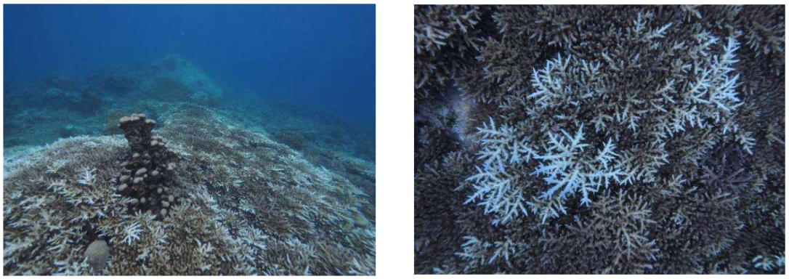
Figure 1. Coral bleaching phenomenon in Hon Bac Island in 2024 (June-July).

Image Quality Requirements:
Images: Submit good quality color images. Each image should be less than 2 MB in size. Size of the image can be reduced by decreasing the actual height and width of the images (keep up to 1600 x 1200 pixels or 5-6 inches). Images can be submitted as JPEG files. Do not zip the files.
Figures: Figures should not be less than 300dpi; with very clear reading content inside or outside.
Units of measurement
Use SI units consistently throughout the manuscript.
Discussion (Times New Roman, 12 pt, Title case, bold)
Discuss the research findings. Subsections may be included as appropriate. The subsection hierarchy should not exceed three levels.
Conclusion (Times New Roman, 12 pt, Title Case, bold)
This section should provide the principal conclusions derived from the research findings, including any study limitations and recommendations for future research directions.

Acknowledgments (Times New Roman, 10 pt, Title Case, bold and italic): Briefly acknowledge funding agencies, institutions, or individuals who contributed to the research but do not meet authorship criteria.
Funding (Times New Roman, 10 pt, Title Case, bold and italic): Provide funding information, including grant numbers where applicable.
Data Availability Statement (Times New Roman, 10 pt, Title Case, bold and italic): Authors should provide a statement describing the availability of the data supporting the findings of the study. Where applicable, datasets should be deposited in a publicly accessible repository, and the corresponding DOI or URL should be provided. Example statements include:
• All relevant data supporting the findings of this study are included within the article and its supplementary materials.
• The data supporting the findings of this study are available from the corresponding author upon reasonable request.
• The datasets generated and/or analyzed during the current study are available in the [repository name] repository at: [DOI/URL].
Authors should ensure that data sharing complies with applicable ethical, legal, institutional, confidentiality, and security requirements.
Author Contributions (Times New Roman, 10 pt, Title Case, bold and italic): Authors are encouraged to describe their contributions using the CRediT (Contributor Roles Taxonomy), where applicable.
Statement on the Use of Generative AI (GenAI) (Times New Roman, 10 pt, Title Case, bold and italic): Authors should disclose whether generative AI tools were used in the preparation of the manuscript. Any use of AI-assisted tools must comply with the Journal’s ethical policies.
* Note: Authors must select one of the following three statements, in accordance with their actual use:
- No AI Used: The authors affirm that no generative AI tools were used to create or modify the scientific content of this manuscript. All analyses, interpretations, and conclusions are entirely the work of the authors.
- Limited AI Use: The authors declare that Generative AI tools were not used to generate or edit the scientific content of this manuscript. Where AI tools were employed (grammar checking/formatting only), the authors have verified all content and take full responsibility for the final version.
- AI Use for Language Editing/Expression/Formatting: The authors declare that AI tools were used only for language editing/formatting, and not for generating scientific content. All data, analyses, and interpretations were performed and verified by the authors, who take full responsibility for the manuscript.
Conflict of Interest Statement (Times New Roman, 10 pt, Title Case, bold and italic): Authors are required to disclose any existing or potential conflicts of interest that could be perceived to influence the research. Financial support should be disclosed in the Funding section. If no conflict exists, authors should clearly state this in the article.
References (Times New Roman, 10 pt, Title Case, bold)
References must be cited in the text and listed alphabetically in the reference section using hanging indentation. References should follow APA 7th edition style. URLs and DOIs, where available, should be included at the end of each reference without a final period.
In-text citation: The Journal adopts the APA (American Psychological Association) 7th edition author-date citation style. All references cited in the text, figures, or tables must appear in the reference list and vice versa.
Supplementary Information (Times New Roman, 12 pt, Title Case, bold)
Supplementary materials are optional and may be submitted to support the manuscript. All supplementary materials should be cited appropriately in the main text.

DETAILED INSTRUCTIONS FOR AUTHORS
1. Line numbering
Authors are required to include continuous line numbering throughout the entire manuscript to facilitate peer review, editing, and communication between authors, reviewers, and editors. Line numbering should start from Line 1 and continue consecutively throughout the manuscript.
Authors should use the continuous line numbering function in Microsoft Word rather than manually inserting line numbers. Line numbers should be included in all sections of the manuscript, including the main text, references, tables, and figure captions, where applicable.
2. Guidelines for citation and annotation
- Ensure that all references are properly cited within the article's content.
- Use the author-date citation style in accordance with the Publication Manual of the American Psychological Association (7th ed.).
- For a work by one author, cite the author's surname followed by the publication year, e.g., (Smith, 2020) or Smith (2020) when the author's name is part of the narrative.
- For a work by two authors, cite both authors' surnames every time the work is cited, using an ampersand in parenthetical citations and "and" in narrative citations, e.g., (Smith & Jones, 2021) or Smith and Jones (2021).
- For a work by three or more authors, cite only the first author's surname followed by et al., e.g., (Smith et al., 2022) or Smith et al. (2022).
- When citing multiple sources within the same parenthetical citation, arrange them alphabetically by the first author's surname and separate them with semicolons, e.g., (Brown, 2019; Smith, 2020; Zhao et al., 2023).
- For multiple works by the same author, arrange citations chronologically, from oldest to most recent, e.g., (Smith, 2018, 2020, 2022).
- When citing multiple works by the same author published in the same year, distinguish them using lowercase letters after the year, e.g., (Smith, 2021a, 2021b).
- For direct quotations, include the page number (or paragraph number when page numbers are unavailable), e.g., (Smith, 2020, p. 97) or (Smith et al., 2022, pp. 45-47).

3. Formulas and Equations
Formulas and equations should be presented using Equation Editor and numbered sequentially from (1) to (n) throughout the article, with the equation numbers aligned to the right. Importantly, formulas should be in an editable text format, not as images. For equations that extend beyond one line, place the equation number on the right of the continued line below. For example:
$A=1-{\left|\frac{Z_{in}-Z_{0}}{Z_{in}+Z_{0}}\right|}^{2}$ (1)
$E_{r}= E_{ru}+ E_{rv}=\hat{u}\left(R_{uu}E_{iu}e^{{iφ}_{uu}}+R_{uv}E_{iv}e^{{iφ}_{uv}}\right)+ \hat{v}\left(R_{vv}E_{iv}e^{{iφ}_{vv}}+R_{vu}E_{iu}e^{{iφ}_{vu}}\right)$ (2)
All formulas and equations should be inserted in the appropriate location within the text. Note the correct format for subscripts and superscripts. For example: H₃PO₄ instead of H3PO4.
4. Tables and Figures
All graphs, tables, and figures originating from external sources must be fully cited and sequentially numbered (Table 1, Table 2, …; Figure 1, Figure 2, …).
Table titles should be positioned above each table. Use a bold label (e.g., Table 1.) followed by a single space and the title in sentence case. Tables should be provided in an editable text format rather than as images. Tables should be self-explanatory and should not duplicate information presented in the main text. Explanatory information should be provided in table footnotes rather than in column or row headings. All non-standard abbreviations used in a table must be defined in the table footnotes.
Figures (including photographs, diagrams, illustrations, charts, maps, and graphs) should be centered on the page without surrounding borders. Figure titles should be placed below the corresponding figure. Use a regular (non-bold) label (e.g., Figure 1.) followed by a single space and the title in sentence case.
Any notes or annotations should be centered, italicized, and not bold. A 6-pt space should be maintained between the title and the corresponding table or figure.
Example of Table:
Table 1. Herbicides in Operation Ranch Hand (Young, 2020).
Herbicides | Spray time | Quantity (thousand tons) | Contaminated area (mil. ha)
Agent Orange | 1962 – 1970 | 57.0 | 1.6
Agent White | 1966 – 1971 | 20.8 | 0.7
Agent Blue | 1962 – 1970 | 10.7 | 0.3
Example of Figure:
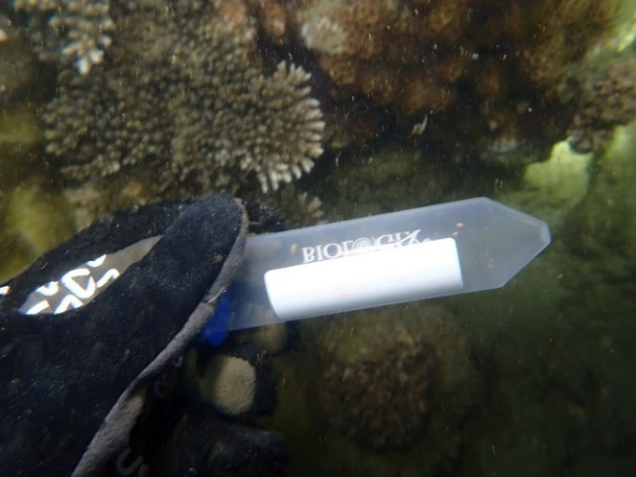
Figure 1. Coral gamete sampling
5. Units of measurement
JTSE follows the International System of Units (SI). A single space should be inserted between the numerical value and the unit symbol (e.g., 15 m, 120 mg/L, 12 kg, 30 °C, 20 μm), except for symbols such as %, °, ′, and ″, where conventional usage may differ. Use the correct SI symbols and capitalization throughout.
Additional guidelines include:
For units of volume (liter, milliliter, etc.), use uppercase letters to prevent confusion with the number “1”. For example, use 2 mg/L; 5.0 mL (not 2 mg/l or 5.0 ml).
For other unit abbreviations, such as kWh, use lowercase as in “kWh” (not KWh).
Ensure consistency with SI conventions by writing “GPa” or “Pa” instead of “Gpa” or “pa”.
6. Guidelines for referencing format
* Author name formatting in references
- Write author names in APA format: Surname, Initial(s).
- For one to 20 authors, list all authors in the order in which they appear in the original publication.
- For 21 or more authors, list the first 19 authors, insert an ellipsis (...), and then add the final author's name. Do not use "et al." in the reference list.
- Use an ampersand (&) before the final author's name.
* Order of references
- Arrange references alphabetically by the surname of the first author.
- References should be formatted with a hanging indent, where all lines after the first are indented.
* Non-English references
- For references in English, the titles should remain unchanged, without transliteration or translation.
- For references published in languages other than English, provide the original title. An English translation of the title may be included in square brackets immediately after the original title, if appropriate. Author names should be romanized (transliterated into the Latin alphabet) where necessary.
* Presentation of references of different types: Pay careful attention to punctuation, capitalization, italics, spacing, and the use of parentheses when formatting references.
- Referencing books:
Format: Author, A. A. (Year). Title of the book (Edition, if not the first). Publisher. https://doi.org/xxxxx (if available).
Example:
Rieder, B. (2020). Engines of order: A mechanology of algorithmic techniques. Amsterdam University Press.
Spudich, J. L., & Satir, B. H. (Eds.). (2001). Sensory receptors and signal transduction. Wiley-Liss.
Council of Biology Editors. (2006). Scientific style and format: The CBE manual for authors, editors, and publishers (6th ed.). Cambridge University Press.
- Referencing a chapter in a book:
Format: Author, A. A. (Year). Title of chapter. In A. A. Editor & B. B. Editor (Eds.), Title of book (Edition, if applicable, pp. xx–xx). Publisher. https://doi.org/xxxxx (if available)
Example:
Young, G. O. (1964). Synthetic structure of industrial plastics. In J. Peters (Ed.), Plastics (2nd ed., Vol. 3, pp. 15–64). McGraw-Hill.
- Referencing articles in newspapers or academic journals:
Note: Include the DOI in URL format (https://doi.org/xxxxx) whenever available.
Format: Author, A. A., Author, B. B., & Author, C. C. (Year). Title of the article. Journal Title, Volume(Issue), xx–xx. https://doi.org/xxxxx
Example:
Liu, G., Lee, K. Y., & Jordan, H. F. (1997). TDM and TWDM de Bruijn networks and shufflenets for optical communications. IEEE Transactions on Computers, 46, 695–701.
Nelson, K. A., Davis, R. J., Lutz, D. R., & Smith, W. (2002). Optical generation of tunable ultrasonic waves. Journal of Applied Physics, 53(2), 1144–1149.
Attapangittya, J. (2003). Social studies in gibberish. Quarterly Review of Doublespeak, 20(1), 9–10.
- Referencing papers in Conference Proceedings:
Format (conference paper): Author, A. A. (Year). Title of paper. In A. A. Editor & B. B. Editor (Eds.), Title of conference proceedings (pp. xx–xx). Publisher. https://doi.org/xxxxx (if available)
Example:
Liu, L., & Miao, H. (2004). A specification based approach to testing polymorphic attributes. In J. Davies, W. Schulte, & M. Barnett (Eds.), Formal methods and software engineering: Proceedings of the 6th International Conference on Formal Engineering Methods (ICFEM 2004) (pp. 306–319). Springer.
Format (entire proceedings):
Editor, A. A., & Editor, B. B. (Eds.). (Year). Title of conference proceedings. Publisher.
Example:
van Weert, T. J., & Munro, R. K. (Eds.). (2003). Informatics and the digital society: Social, ethical and cognitive issues. Kluwer Academic.
- Referencing Theses and Dissertations:
Format: Author, A. A. (Year). Title of thesis (Master's thesis or Doctoral dissertation, Institution). Repository or Database (if applicable). URL (if available).
Example:
Williams, J. O. (1993). Narrow-band analyzer (Doctoral dissertation, Harvard University).
- Referencing Online Documents:
Format: Author, A. A. (Year, Month Day). Title of document. Website Name. URL
If there is no individual author, begin with the organization responsible for the content. Include a retrieval date only when the content is designed to change over time (e.g., wikis).
Example:
Ayasso, H., & Mohammad-Djafari, A. (2010). Joint NDT image restoration and segmentation using Gauss-Markov-Potts prior models and variational Bayesian computation. IEEE Transactions on Image Processing, 19(9), 2265–2277. https://doi.org/xxxxx
Altun, A. (2005, July). Understanding hypertext in the context of reading on the web: Language learners' experience. Current Issues in Education, 6(12). http://cie.ed.asu.edu/volume6/number12/

